**CHAPTER-1**

**INTRODUCTION**

**1.1 Introduction and motivation**

Scientific discoveries are being made every day that are changing the world we live in. From physics to medicine to biology, this contains some crazy innovations. Further advances in computing technology have helped with efficiency in the analytical chemistry laboratory in many ways. The first one is automation and simplification of analytical and synthetic tasks, which includes the use of computer controlled technology and measurement system to improve the accuracy, repeatability and increased utilization of equipment. Recent enhancements in computing technology and low cost capabilities of computing trends have resulted in a new generation of automated analytical instruments. Further the huge development of microelectronics and embedded automation systems changing the way we work, and also making us to be free from tedious tasks. Advancement in biometric devices in biomedical fields has become preventing and treating the disease easily. The small scale chips and microcontrollers holding a very large key in development of the biotechnology.

**1.2** **Blood pressure**

Blood pressure is the amount of force exerted by the blood against the walls of the arteries. A person's blood pressure is considered high when the readings are greater than 140 mm Hg systolic (the top number in the blood pressure reading) or 90 mm Hg diastolic (the bottom number). In general, high blood pressure, or hypertension, contributes to the development of coronary heart disease, stroke, heart failure and kidney disease.

Although many pregnant women with high blood pressure have healthy babies without serious problems, high blood pressure can be dangerous for both the mother and the fetus. Women with pre-existing, or chronic, high blood pressure are more likely to have certain complications during pregnancy with normal blood pressure. However, some women develop high blood pressure while they are pregnant (often called gestational hypertension).

The effects of high blood pressure range from mild to severe. High blood pressure can harm the mother's kidneys and other organs, and it can cause low birth weight and early delivery. In the most serious cases, the mother develops preeclampsia - or "toxemia of pregnancy"--which can threaten the lives of both the mother and the fetus.

**1.2.1 High BP in Pregnancy**

Most women with chronic hypertension have uneventful gestations as long as their BP remains at (or is controlled to) levels considered “mild to moderate.” In contrast, preeclampsia is associated with many serious complications. Thus, early and accurate recognition and differentiation of preeclampsia from other causes of high BP in pregnancy has important implications regarding management. A precise diagnosis, however, is not always possible, in which case it is best to manage the woman as if she has preeclampsia, which is the more serious disorder with a broad clinical spectrum.

Preeclampsia, a protein disorder that involves many organ systems, is primarily characterized by hypertension and proteinuria. The latter is defined by excretion of 300 mg/24 hours, a urine protein/creatinine ratio of 0.3, or a qualitative 1 dipstick reading. The dipstick value of 1 has many false-positive and false-negative results and is the least useful. Accurate, timed urine collections are very difficult to obtain during pregnancy, and, theoretically, a urine creatinine/protein ratio eliminates such errors. However, the accuracy of this test is still being investigated. Preeclampsia may also be accompanied by rapid weight gain and edema, appearance of coagulation or liver function abnormalities, and occurs most often in nulliparas, usually after gestational week 20, and most frequently near term. Attempts have been made to categorize preeclampsia as “mild” or “severe”. The latter are often defined on the basis of BP levels (110 mm Hg diastolic an160 mm Hg systolic), the appearance of nephrotic range proteinuria, sudden oliguria, neurologic symptoms.

**1.2.2 Preeclampsia**

Preeclampsia is a condition that typically starts after the 20th week of pregnancy and is related to increased blood pressure and protein in the mother's urine (as a result of kidney problems). Preeclampsia affects the placenta, and it can affect the mother's kidney, liver, and brain. When preeclampsia causes seizures, the condition is known as eclampsia--the second leading cause of maternal death in the U.S. Preeclampsia is also a leading cause of fetal complications, which include low birth weight, premature birth, and stillbirth.

There is no proven way to prevent preeclampsia. Most women who develop signs of preeclampsia, however, are closely monitored to lessen or avoid related problems. The only way to "cure" preeclampsia is to deliver the baby.

Unfortunately, there is no single test to predict or diagnose preeclampsia. Key signs are increased blood pressure and protein in the urine (proteinuria). Other symptoms that seem to occur with preeclampsia include persistent headaches, blurred vision or sensitivity to light, and abdominal pain. Be sure your blood pressure is under control. Lifestyle changes such as limiting your salt intake, participating in regular physical activity, and losing weight if you are overweight can be helpful.

**1.3** **Body Temperature**

Temperature is a measure of the degree of heat intensity. The temperature of a body is an expression of its molecular excitation. The temperature difference between two points indicates a potential for heat to move from the warmer to the colder point. The human body’s core temperature varies from day to day, and from time to time, but these fluctuations are small, usually no more than 1.0ºC. Humans are homoeothermic and body temperature is regulated at about 37ºC ±1ºC. The thermoregulatory center in the hypothalamus plays a very active role in keeping body temperature in the normal range. External and internal heat sources influence body temperature.

Body temperature is maintained through a balance of the heat produced by the body and the heat lost from the body.

**1.4 OBJECTIVE OF THE REPORT**

The methods used previously were the blood pressure was measured using oscillometric method using PPG sensor. The main objective of the method is to reduce the device complexity and increase the flexibility for pregnant women who need constant monitoring of blood pressure and weight. These two when constantly monitored would lead to reduced effects of preeclampsia. The simple box containing pressure sensor is interfaced to the microcontroller. The load cell is interfaced with the load cell controller chip in order to get the load cell output in terms of analog to digital. Further, the devices designed now a days usually measure either of the two blood pressure, temperature or the weight but not both. This paper focuses on designing the device which gives us the benefit of all the three measurements in one kit. Considering the changes the devices gives out the measurement of weight, blood pressure and temperature which is basically needed for monitoring a pregnant women.

**1.5 PROBLEM DEFINITION**

The devices so far implemented are either measuring blood pressure, temperature or weight but not all at the same time. Also the device complexity and accuracy along with speed is taken into consideration. The methods used were the general oscillometric method which was useful for 24hr BP measurement but was at the same time constantly monitoring over the armband. Also the device used contained PPG sensor and few other electrodes which makes the equipment tedious.

**1.6 ORGANIZATION OF THESIS**

The thesis is organized as follows:

**Chapter 2**: the detailed description of the methods being used for blood pressure and temperature measurement is given also the device used to implement the process has been discussed so far. The detailed explanation about the existing system is discussed.

**Chapter 3**: The detailed description of the proposed system designing of an arm band wearable device for blood pressure, temperature and weight measurement for pregnant women is discussed.

**Chapter 4**: The detailed description of the development tools required to implement the project is discussed.

**Chapter 5**: It gives the detailed description of the simulation results of the project implemented and also analyzing the flowchart of the system.

**CHAPTER 2**

**LITERATURE REVIEW**

**2.1 SYSTEM AND METHOD**

The system and method used for measuring BP is often seen with oscillometric variations. The device used is usually showing analog signals for measurement of the device, where the result may seem accurate but is complex for understanding of a common man. Also the digital devices used for measuring the blood pressure seem inaccurate. Hence, forth the device is implemented in such a way that the results obtained for reading is accurate and also can be understood by the common man. The wearable devices have been existing in the market for implementation of blood pressure monitoring and temperature measurement.24-h ambulatory BP monitoring is being increasingly adopted in clinical diagnosis and treatment of hypertension. Other related parameters, such as nighttime BP and BP variability, have been proved to be capable of providing independent clinical values in the prediction of CVD events. Though the significance of ambulatory BP monitoring in the clinical practice has been recognized, the present BP measurement devices are mainly cuff-based, which may cause discomfort due to the inflation of cuff during measurement, and are thus unsuitable for long-term BP monitoring, especially during nighttime. Pulse transit time (PTT), defined as the time for the pulse to travel from the heart to a peripheral site, and has been proposed to be a potential surrogate of BP. An armband-based wearable monitoring device shown in Fig.2.1 was developed for ambulatory ECG and PPG measurement. ECG was measured by three electrodes. This wearable device is an improved version of the system we reported in .In this system, to avoid long wires across the body, two e-textile electrodes were sewed in the armband wrapped around the left arm, and the other one adopted the adhesive Ag–Ag/Cal electrode which was placed on the right side of the subject’s thorax. One electrode on the armband works as a common electrode with the right leg driven circuit to actively cancel common-mode interference.

PPG was measured by near-infrared LED emitter and a phototransistor in reflective mode. The acquired ECG and PPG were amplified and filtered by band-pass filters with frequency band of 0.5–17 and 0.5–10 Hz, respectively. The filtered analog signals were digitalized by a microcontroller unit (MCU, AT mega 8) at the sample rate of 500 Hz and resolution of 8-bit, and then stored in a flash memory module mounted on the armband. To save power, the MCU was programmed to switch on the powering circuit every 30 min and then switch off after 1 min data recording. A buzzer was used for reminding the subject to keep still during signal recording to avoid motion artifacts.

**2.2 Mechanism of the system**

The measurement principle of this 24-h ambulatory BP monitor, however, makes it difficult to obtain synchronized BP and Temperature measurements during a 24-h period. First, although the two devices were set to have the same sampling rate (one sample per 30 min), they tend to be out-of-sync a few hours after the start of the study due to the built-in sampling pattern of the 24-h ambulatory BP monitor. Second, using a cuff inflation to trigger the recording of PTT can better synchronize the two devices but such a design was not adopted due to other practical issues:

1) If a physical cable was used to connect the two devices that were placed on the two arms of a subject, it would cause great inconvenience to the subject and therefore the design is not recommended by the doctor.

2) If wireless communication such as Bluetooth was used, the heavy power consumption of the wireless module is found to be impractical for the 24-h study.

In order to get the measured outputs without the manometer this mechanism has been modified with the replacement of Sphygmanometer to a simple pressure sensor for measuring the blood pressure and temperature along with the weight. The fundamental concept of relating BP with PTT is based on Moens–Korteweg equation which expressed PWV in terms of the elastic modulus of the artery wall for lateral expansion (*E*in ), the thickness of the arterial wall (*h*), the radius of the artery at the end of diastole (*r*), and the density of blood (*ρ*), i.e.,

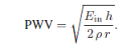

In addition, the mathematical representations of the elasticity or compliance of arterial wall as a function of BP are needed to arrive at an equation that allows the estimation of BP from PWV. A very commonly used experimental finding is based on the in vivoand in vitrostudies on 12 anaesthetized dogs by Hughes. This study concluded that the elastic modulus (*E*in ) increased exponentially with the mean BP (MBP) of the dogs’

Descending thoracic aorta in vivo, i.e.

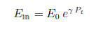

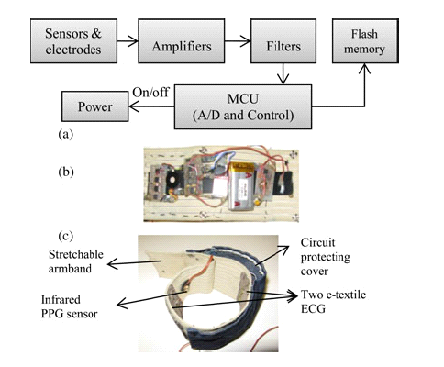

FIG 2.2 Armband wearable devices for 24 h ECG and PPG measurement.

(a) Block diagram of the system. (b) Circuitry of the system. (c) Final package

in a stretchable armband

**2.3 OBJECTIVE OF THE PROJECT**

The aim of the project is to design the system for temperature, weight and blood pressure measurement for pregnant women. Women with pregnancy-related disorders are unique for a number of reasons: (I) as their disorder is pregnancy related, the disorder will be cured automatically after child birth; (ii) the patients are relative young in comparison to the majority of patients, who are older than 65 years; young patients have more interest in applying modern technology such as smart phones to the management of their disease; (iii) pregnant women have a strong wish to be actively involved in improving the health of both their child and their own and be informed, about relevant decisions made by healthcare professionals, in particular midwives and gynecologists, during the course of their pregnancy.

Furthermore, depending on its severity preeclampsia can be further classified as mild or severe.

Mild preeclampsia is defined as systolic blood pressure (SBP) ¸ 140 mmHg and diastolic blood

Pressure (DBP) ¸ 90 mmHg, accompanied by > 1+ proteinuria. The majority of patients will

Only have mild disease, but an important, and largely unpredictable, subset will progress to the

Severe syndrome, which is defined by one of the following criteria:

• SBP ¸ 160 mmHg or DBP ¸ 110 mmHg.

Pre-eclampsia or preeclampsia is a disorder of pregnancy characterized by high blood pressure and large amount of protein in the urine. Though present in the majority of cases, protein in the urine need not be present to make the diagnosis of preeclampsia. It involves many body systems and evidence of associated organ dysfunction may be used to make the diagnosis when hypertension is present. This includes the presence of a low blood platelet count, impaired liver function, and the development of new kidney dysfunction, fluid accumulation in the lungs, and/or new-onset brain or visual disturbances. If left untreated, preeclampsia can develop the life-threatening occurrence of seizures during pregnancy. Preeclampsia is associated with multiple maternal and fetal adverse effects.

**2.3.1 ADVANTAGES:**

The advantage of this model is that only one calibration point is needed to determine the individual parameter, which is important for the practical use of this method. In this study, the first measurements of BP and PTT were adopted for calibration, and the rest of the data were used for validating the accuracy of this model. The difference between the PTT-based estimation and the reference device was compared between the two methods\ (Methods 1 and 2) as well as between different references (raw and smoothed SBP).The present method used in our project is to reduce the complexity of the device by using simple pressure sensor directly rather than PPT measurement or oscillometric measurement.

**2.3.2 LIMITATIONS**

In this study, an armband-based wearable device was developed for long-term BP measurement based on PTT method. 24-h take-home study was conducted to evaluate the accuracy of this device. To overcome the difficulties of misalignment in time between the recordings from the PTT-based wearable device and the oscillometric-based reference device, a new analysis method was proposed to preprocess PTT. The results showed that the correlation between SBP and PTT during nighttime was significantly improved by the proposed method to *−*0.62 *±* 0.21with the difference between the PTT-based estimation and the reference SBP in 2.8 *±* 8.2 mmHg. The limitations of this project was overcome and replaced by few of the techniques.

**2.4 PROPOSED MECHANISM**

The proposed project will overcome the drawbacks of the devices observed and therefore following modifications are done by replacing the devices. In the previous cases the sensors used were PPG sensor for temperature and blood pressure measurement and also electrodes were used for measuring the pulses and BP. The block diagram and the mechanism used will be improvised by some of the replaced methods from the recently implemented methods in order to make it more feasible and cost effective. The microcontroller atmega8 is replaced with ARM7 which has larger benefits from the previous implemented methods.

Hence designing the signal conditioning interface based on the type of sensor such as pressure and temperature sensor. We simulate the circuits in proteus software to verify their accuracy. We also simulate the temperature simulated results to verify the linearity of the temperature against the output voltage. Therefore, the design will be useful for the patient monitoring systems which use microcontroller for interpretation before sending them to the guardian/doctor through mobile phone network assisted by GSM/GPRS modem.

**2.5 SUMMARY**: In this chapter, we discussed the existing system which consists of 24hr blood pressure measurement using oscillometric method. The system is only capable of measuring blood pressure over the arm using three electrodes and a PPG sensor.

**CHAPTER 3**

**BLOCK DIAGRAM OF THE SYSTEM**

**3.1 SYSTEM DESIGN**

The block diagram of the system consists of the following modules:

* ARM ( LPC2148)
* BLOOD PRESSURE SENSOR (MPX10GP)
* TEMPERATURE SENSOR (LM35)
* LOAD CELL (CZL-601AC)
* BUZZER
* LCD DISPLAY
* GSM Modem

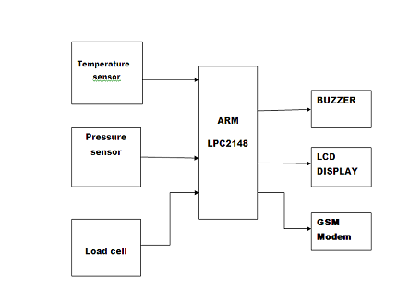

Fig 3: Block diagram of system

**3.2 ARM 7 (LPC 2148)**

ARM stands for Advanced RISC Machine developed by ARM Ltd which is most widely used in number of embedded systems. Today ARM family accounts for approximately 75% of all embedded CPUs making it one of the leading architecture in the world. Previous designs used 8 bit/16 bit devices, but the designers are looking for highly integrated high performance ARM based 32-bit microcontroller. Heart of the design is ARM 32 bit RISC processor, hence brief description was given about its specifications below. The basic block diagram of the system is as shown in fig 3.1, the system shows the Fluctuation in the normal blood pressure and body temperature of the patient will be sensed by the Bp sensor

And temperature sensor. The body temperature will be directly sent to the microcontroller by the LM 35 temperature sensor.

The LPC2148 board consists of ARM7TDMI as its core and it is designed by NSK shown in Fig 1, which is helpful to students to design embedded applications. This kit is benefit for the students in such way that all the possible features of the microcontroller will be easily used by them. ARM7TDMI family has good performance in situations where the energy consumption is critical design goal. LPC2148 has ARM7TDMI as its core is called CPU core. The modules inside are connected by the CPU high performance bus called Advance High performance bus (AHB) and the peripherals are connected by VLSI peripheral bus (VPB).

LPC 2148 has 2 types of memory. a. Flash memory 512KB b. Static RAM 40KB

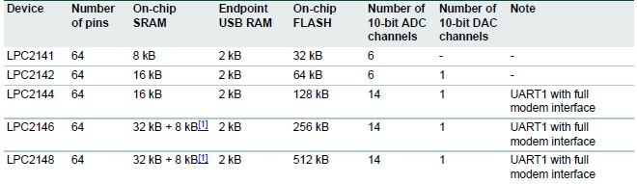

Table 3.2: Device information

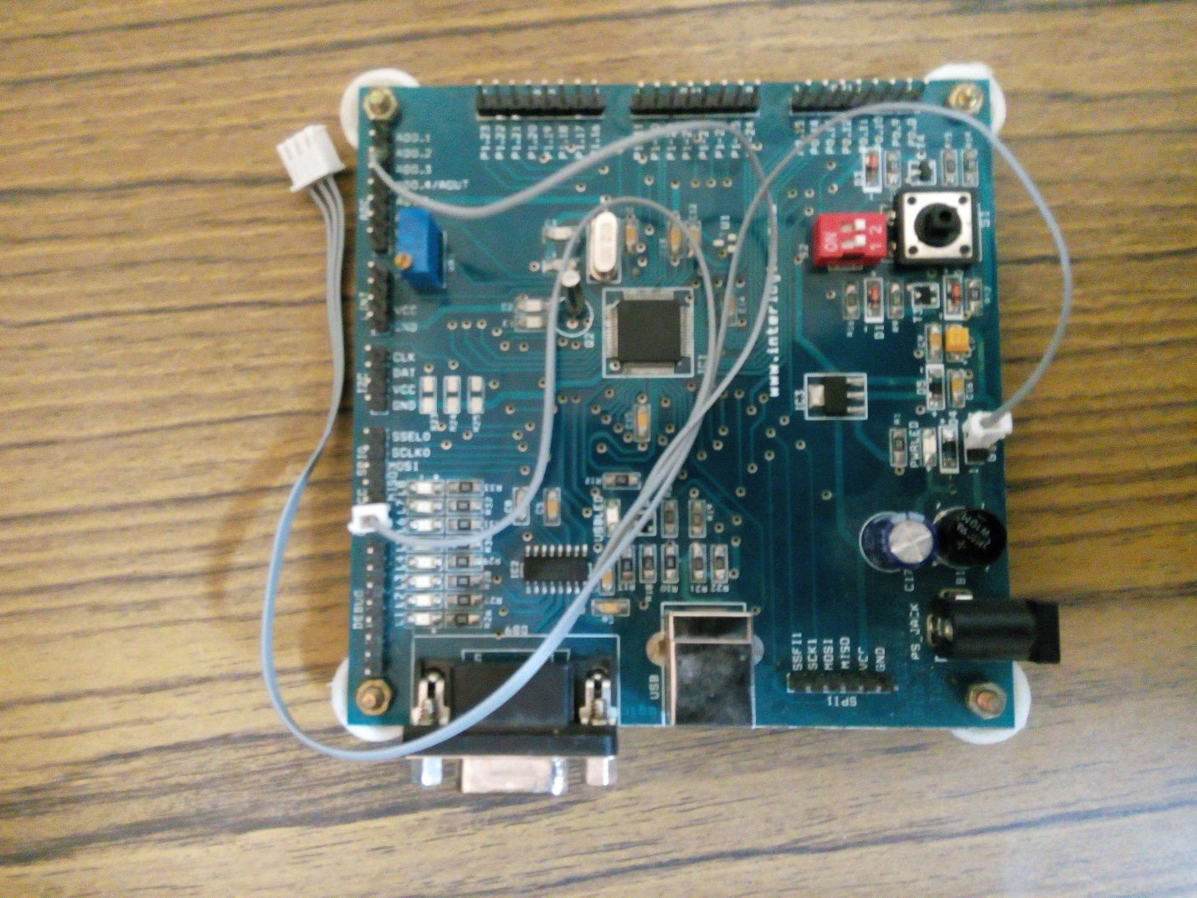

Fig 3.2 LPC2148 kit

**3.3 BLOOD PRESSURE SENSOR**

The blood pressure sensor used is MPX10GP and is used in place of manometer.The MPX10 series piezoresistive transducer is a state-of-the-art monolithic silicon pressure sensor designed for a wide range of applications, but particularly those employing a microcontroller or microprocessor with A/D inputs. This patented, single element transducer combines advanced micromachining techniques, thin-film metallization, and bipolar processing to provide an accurate, high level analog output signal that is proportional to the applied pressure.

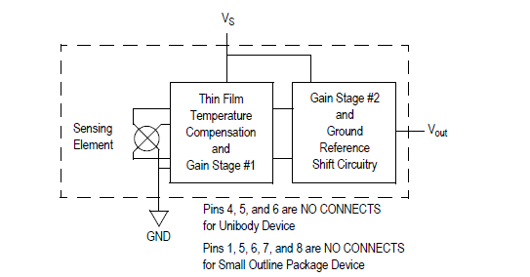

Fig 3.3 .Fully integrated pressure sensor schematic

NOMINAL TRANSFER FUNCTION:

Vout = VS (P x 0.018 + 0.04) ± (Pressure Error x Temp. Factor x 0.018 x VS)

VS = 5.0 V ± 0.25 Vdc

**3.3.1 Prototype**

Fig. 3.3.1 shows the experimental setup of the mobile BP measure device. The manometer is removed from a traditional sphygmomanometer and its tube connected to the pressure sensor on the PCB. The latter is encased in a free confectionary enclosure and interfaced to the arm kit lpc2148 using a standard cable. The final prototype has all the characteristics described in the methods section.

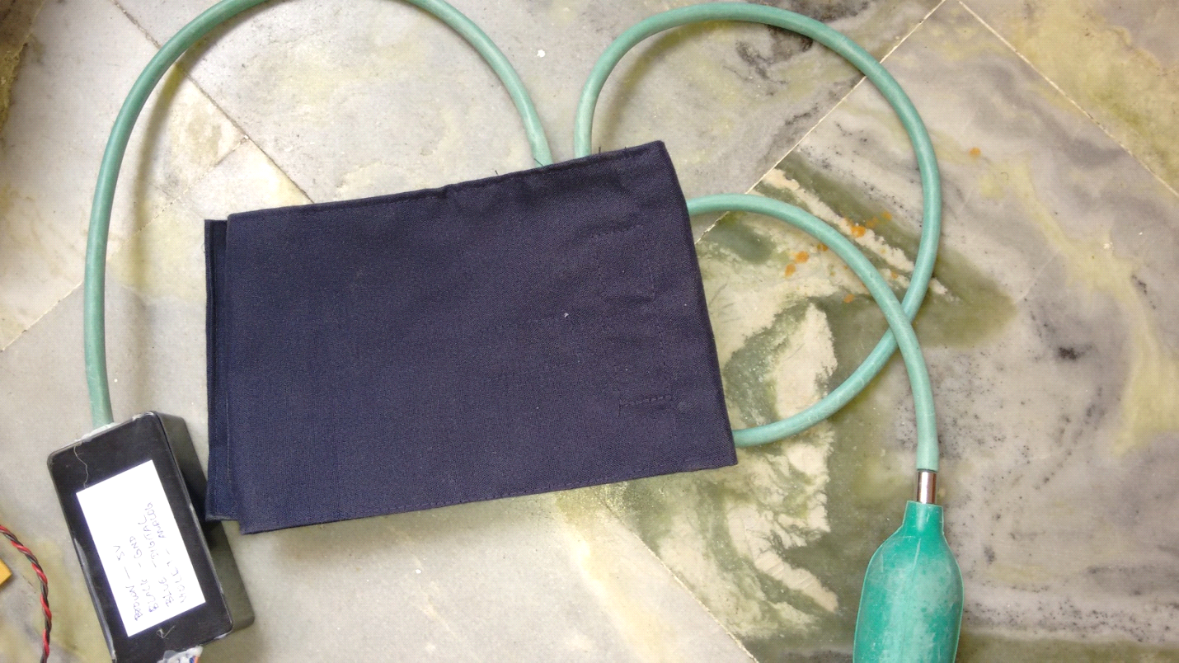

**Fig 3.3.1 Prototype**

**3.4 Temperature sensor**

The LM35 series are precision integrated-circuit temperature sensors, whose output voltage is linearly proportional to the Celsius (Centigrade) temperature. The LM35 thus has an advantage over linear temperature sensors calibrated in° Kelvin, as the user is not required to subtract a large constant voltage from its output to obtain convenient Centigrade scaling. The LM35 does not require any external calibration or trimming to provide typical accuracies of ±1⁄4°C at room temperature and ±3⁄4°cover a full −55 to +150°C temperature range. Low cost is assured by trimming and calibration at the wafer level. The LM35’s low output impedance, linear output, and precise inherent calibration make interfacing to readout or control circuitry especially easy. It can be used with single power supplies, or with plus and minus supplies.

**3.4.1 Features**

* Calibrated directly in ° Celsius (Centigrade)
* Linear + 10.0 mV/°C scale factor
* 0.5°C accuracy guarantee able (at +25°C)
* Rated for full −55° to +150°C range
* Suitable for remote applications
* Low cost due to wafer-level trimming
* Operates from 4 to 30 volts
* Less than 60 μA current drain
* Low self-heating, 0.08°C in still air
* Nonlinearity only ±1⁄4°C typical
* Low impedance output, 0.1 W for 1 mA load

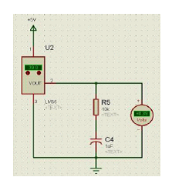

Fig 3.4.1(a) Temperature sensor schematic

The LM35 is rated to operate over a −55° to +150°C temperature range, while the LM35C is rated for a −40° to +110°C range (−10° with improved accuracy). The LM35 series is available packaged in hermetic TO-46 transistor packages, while the LM35C, LM35CA, and LM35D are also available in the plastic TO-92 transistor package. The LM35D is also available in an 8-lead surface mount small outline package and a plastic TO-220 package.

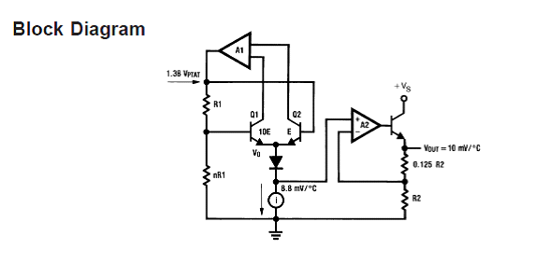

Fig 3.4.1(b) Block diagram schematic of LM35 Sensor

**3.4.2 Characteristics of LM35 sensor**

The LM35 simulated results were analyzed and implies that the output voltage is linearly proportional to the Celsius temperature as shown in fig 3.4.2.

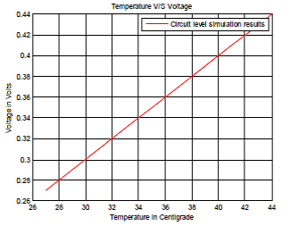

Fig 3.4.2 Characteristics of temperature sensor

**3.5 LOAD CELL**

When the minimum weighing value (1 digit) is small compared to the rated capacity, the load cell output per digit should be above the input sensitivity of the indicator. Force applied onto the weighing pan is converted into electrical signals by the load cell and output to the indicator.

Suppose the specifications of the load cell are as follows:

Rated capacity: 6 kg

Rated output: 1 mV/V

Recommended excitation voltage: 10 V

When the rated output is 1 mV/V and the excitation voltage is 10 V, the load cell will output 10 mV to the indicator. This is the output voltage when the rated capacity of 6 kg is loaded.

(Load) 6 kg → 10 mV (Output Voltage)

Load cell specifications must be checked to ensure that they satisfy the required accuracy of

Measurement. The factors that influence the accuracy are nonlinearity, hysteresis error, repeatability, and temperature effects on zero balance and span. Recently, it is more common to express nonlinearity, hysteresis error, and repeatability together as the combined error.

When the required accuracy is represented as ε, one of the following formulas applies:

(1) If the combined error is specified in the catalog,

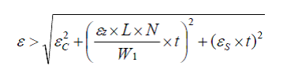

ε : Measurement accuracy of the load cell (%)

εC : Combined error (%)

εZ : Temperature effect on zero balance (%/˚C)

εS : Temperature effect on span (%/˚C)

L : Rated capacity of the load cell

N : Number of load cells to be used

W1: Maximum load to be measured

T: Temperature variation range of the load cell (˚C)

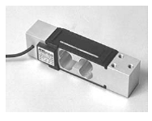

Fig 3.5 LOAD CELL

Nowadays digital load cells are still niche products. They are available as calibrated C3

and C6 cells as well as uncalibrated types. Typical applications are set-ups with long wires

(where the digital signal transmission is better than analog), when several load cells are

processed by one single controller, e.g. truck scales or in electromagnetical noisy environments.

The advantages can therefore be concluded as:

1. Long cable lengths possible without loss in signal strength

2. Combination of several load cells processed by a single processor

3. Reduced sensitivity to EMI

4. Good replace ability as intrinsically calibrated cells

In order to get a more detailed picture of what a digital load cell is or how its concept is

Like we have a look at its set-up nowadays. As mentioned in the introduction it basically

consists of the load cell itself combined with the electronics which is a converter and a

microcontroller:

The signal generated by the strain gages on the load cell are given to the electronics.

Here an A/D converter digitizes the analog signal and feeds the microcontroller

or DSP with the A/D raw count. The controller processes then the raw values, corrects them in terms of linearization, filtering, hysteresis, etc. and finally puts out the digital signal.



Fig.3.5 (a): Digital Load Cell set-up nowadays

A nowadays production of digital load cells faces the following items amongst others:

1. Mounting and assembling of load cell and electronics separately

2. Calibration of load cell and electronics separately, the summary error needs to match legal specifications.

3. High efforts are needed for temperature compensation of gain and offset

4. Manual trimming of the load cell’s adjustment resistors means a lot of hand work

5. Long throughput times due to iterative temperature drift tests

**3.6 GSM Modem and Buzzer:**

The GSM modem is used to send the text message to the given number in case the blood pressure becomes high and the buzzer is activated and gives a beep sound. The GSM Modem used in the system is basically a sim900 piece and is used for sending the messages effectively. The sim has to be placed in the slot available in the GSM Modem and interfaced to the microcontroller . An external power supply of 5V is to be given to the GSM Modem. The buzzer is being already interfaced to the lpc2148 for buzzing sound to make the people alert in case of high blood pressure.

The GSM modem needs to have allotted a slot for separate sim card along with the balance for initiation. Also the mobile phone to which the message is being sent should also contain/ do not contain balance in it. Although the signal strength must be taken into consideration for the system to work effectively.

**3.7 SUMMARY**

In this chapter, the detailed description of the system built and the devices used with the brief explanation is discussed. Each device is given with their respective features and functionalities along with the characteristics. The protocols used here are all interconnected accordingly to their respective peripherals.

**CHAPTER 4**

**DEVELOPMENT TOOLS**

The project uses the following development tools for the implementation of the device, in real time:

* Keil micro version 4
* Flash magic

**4.1 KEIL MICRO VERSION 4**

Keil development tools, designed for ARM processor-based microcontroller devices, support every level of developer from the professional application engineer to the student just learning about embedded software development. The industry-standard Keil C/C++ Compilers, Macro Assemblers, Debuggers, Real-Time Kernels, and Single-board Computers support ALL ARM-compatible derivatives and help you in getting your projects completed on schedule. The Keil MDK-ARM Microcontroller Development Kit, (Keil MDK-ARM), tools generate embedded applications for many popular ARM-powered devices. The tools allow engineers to write software programs in assembly language or in a high-level language (like C or C++), and to create a complete application that can be programmed into a microcontroller or other memory device. The Keil MDK-ARM development tools are designed for the professional software developer, but any level of programmer can use them to get the most out of the ARM7/9 and Cortex-M microcontroller.

**4.1.1 Building an application in u vision4**

To build (compile, assemble, and link) an application in µVision4, you must:

* Select Project - Open Project.
* If loading a µVision3 project, change the file filter in the Select Project File dialog to Previous Project Files (*.uv2; *.uv3; *.mpw).
* Select the project to load (for example, \ARM\EXAMPLES\MEASURE\MEASURE.UV2).
* Select Project - Rebuild all target files or Build target.

µVision4 compiles, assembles, and links the files in your project.

**4.1.2 Debugging an application in uvision4**

To debug an application created using µVision4, you must:

* Select Debug - Start/Stop Debug Session.
* Use the Step toolbar buttons to single-step through your program. You may enter G,main in the Output Window to execute to the main C function.
* Open the UART #2 Window using the Serial Windows - UART #2 button on the toolbar.
* Debug your program using standard options like Step, Go, Break, and so on.

**4.1.3 Creating your own application in uvision4**

To create a new project in µVision4, you must:

* Select Project - New Project.
* Select a directory and enter the name of the project file.
* Select Project - Select Device and select an ARM, 8051, 251, or C16x/ST10 device from the Device Database™.
* Create source files to add to the project.
* Select Project - Targets, Groups, and Files. Add/Files, select Source Group1, and add the source files to the project.
* Select Project - Options and set the tool options. Note when you select the target device from the Device Database™ all special options are set automatically. You typically only need to configure the memory map of your target hardware. Default memory model settings are optimal for most applications.
* Select Project - Rebuild all target files or Build target.

**4.2 Flash magic**

Flash Magic is Windows software from the Embedded Systems Academy that allows easy access to all the ISP features provided by the devices. These features include:

* Erasing the Flash memory (individual blocks or the whole device)
* Programming the Flash memory
* Modifying the Boot Vector and Status Byte
* Reading Flash memory
* Performing a blank check on a section of Flash memory
* Reading the signature bytes
* Reading and writing the security bits
* Direct load of a new baud rate (high speed communications)
* Sending commands to place device in Boot loader mode

Flash Magic provides a clear and simple user interface to these features and more as

Described in the following sections. Under Windows, only one application may have access the COM Port at any one time, preventing other applications from using the COM Port. Flash Magic only obtains access to the selected COM Port when ISP operations are being performed. This means that other applications that need to use the COM Port, such as debugging tools, may be used while Flash Magic is loaded. Note that in this manual third party Compilers are listed alphabetically. No preferences are indicated or implied.

The window is divided up into five sections. Work your way from section 1 to section 5 to

program a device using the most common functions. Each section is described in detail in the following sections.

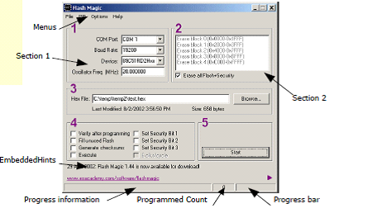

Fig 4.2.1: Flash magic window

At the very bottom left of the window is an area where progress messages will be displayed

and at the very bottom right is where the progress bar is displayed. In between the messages and the progress bar is a count of the number of times the currently selected hex file has been programmed since it was last modified or selected. Just above the progress information Embedded Hints are displayed. These are rotating Internet links that you can click on to go to a web page using your default browser. If you wish to quickly flick through all the hints then you can click on the fast forward button:

**4.3 SUMMARY**

In this chapter, the detailed description of the development tools being used in the project is focused like proteus for implementing on the virtual platform and keil for developing the system and flash magic in order to dump the real time project.

**CHAPTER 5**

**SIMULATION RESULTS**

**5.1 Introduction**

The simulation results are obtained by dumping the program on a keil development software in this chapter.

The program is described by partitioning the work process into few more sub modules into it. The overall process is lengthy and so the whole program cannot be written into one main program.

In order to reduce the complexity the main programs contain the related header files to subdivide the modules and make programming it on keil platform easy.

**5.2 Simulation Result Analysis**

Sub modules / header files involved in programming the main function are as follows:

* Main function
* ADC Programming
* Serial Programming
* LCD Programming
* Timer Programming
* Program for the Weight/ Load cell

The next process involves dumping the whole program through the serial communication port onto the ARM7 microcontroller and displayed onto the LCD using Flash Magic development software.

**5.2.1 INPUT OF THE PROPOSED SYSTEM**

First run the program on Keil software and this program is to be dumped onto the flash magic for further implementation using uart communication.

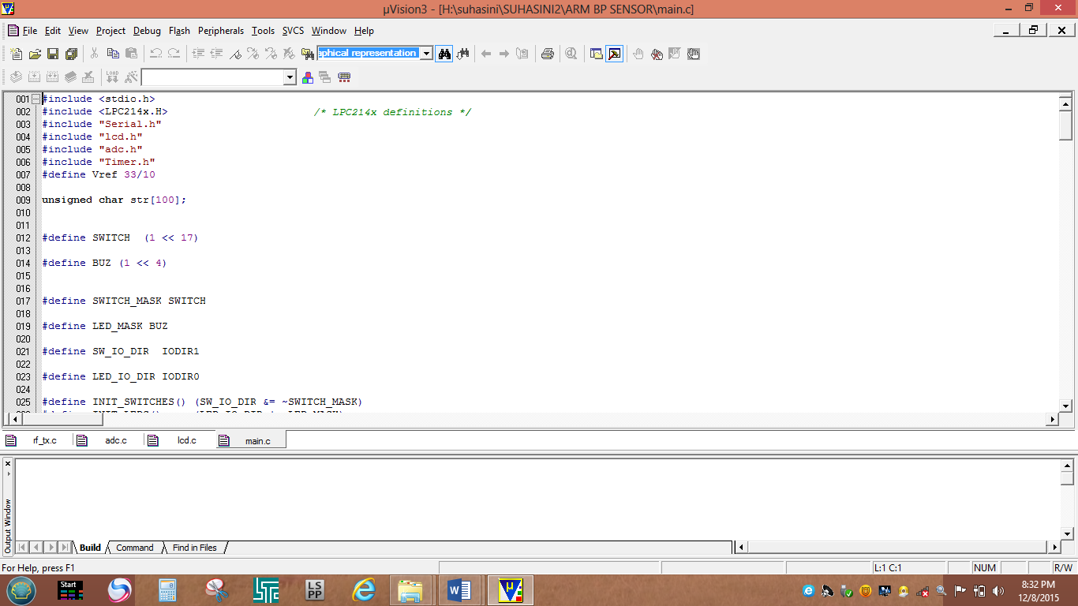

**Fig 5.2.1 Main program execution with respective header files**

In the above shown fig 5.2.1 the main program contains the header files also said to be the subfuctions of the programs involved which function on the basis of loop functionality one after the other in the hierarchy produced. Each are defined by their functions and are port assigned individual ports of the ARM7 controller as the microcontroller have large set of ports which makes it easy to allocate the functions.

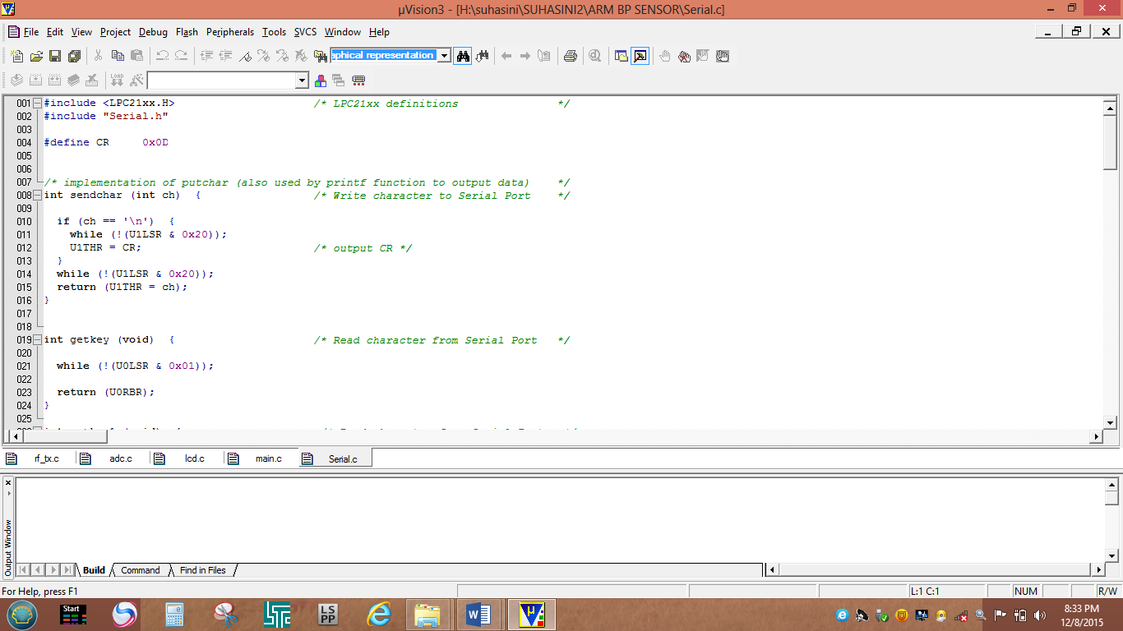

**Fig 5.2.2 Serial program execution (header file of main directory)**

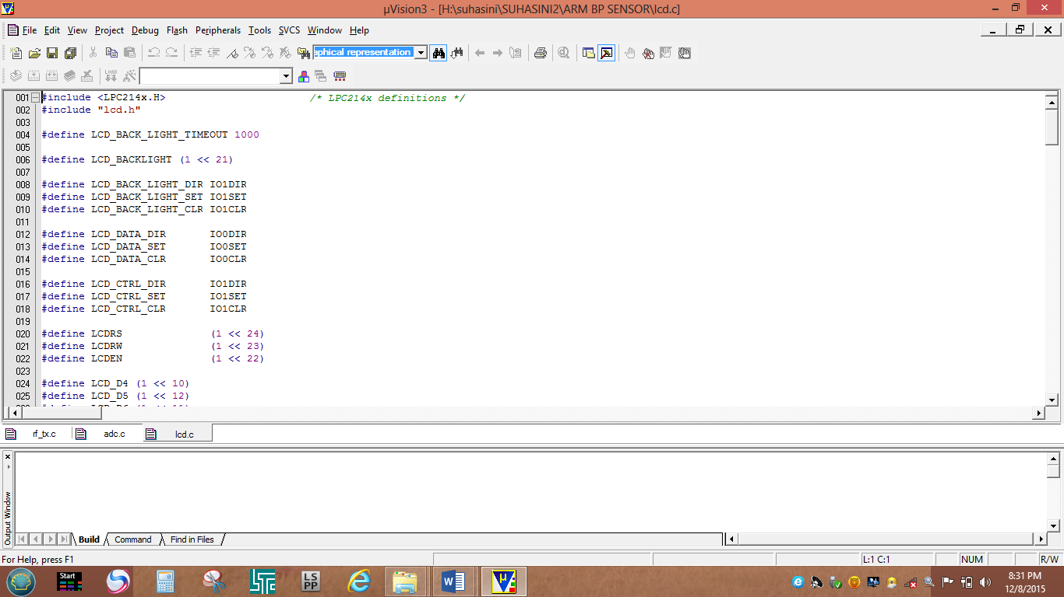

**Fig 5.2.3 LCD program execution (header file of main directory)**

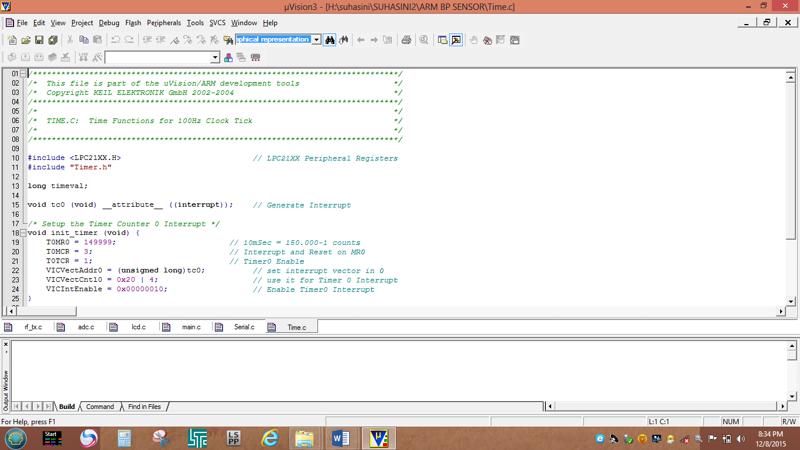

**Fig 5.2.4 Timer program execution (another header file of main directory)**

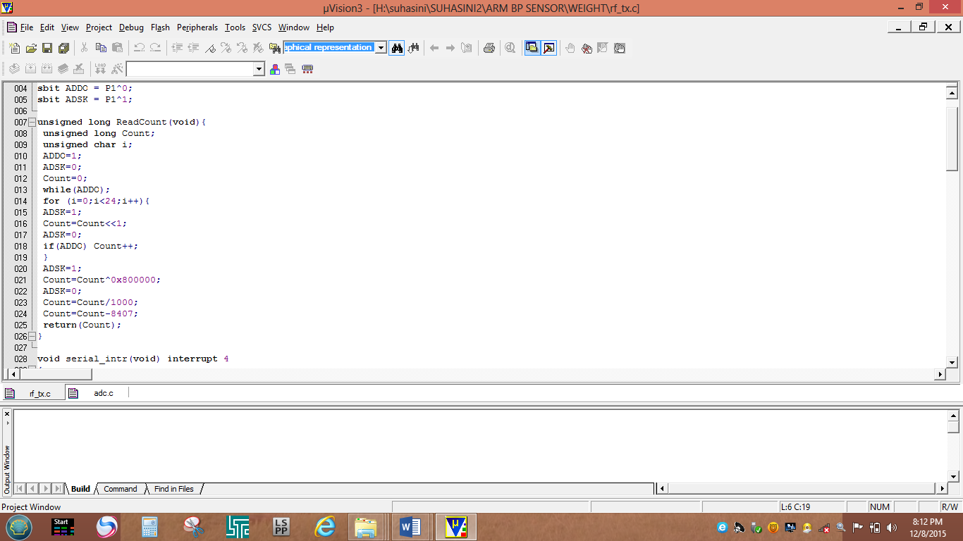

**Fig 5.2.5 Load cell execution (file of the main directory)**

Outputs are displayed onto the LCD and the process of checking the estimated values are displayed when the power supply is turned on. At first stage of the process, the values of temperature and weight are taken into consideration, later the temperature value is recorded in terms of Fahrenheit as shown in fig. Then the reading are to be noted as per the lcd display.

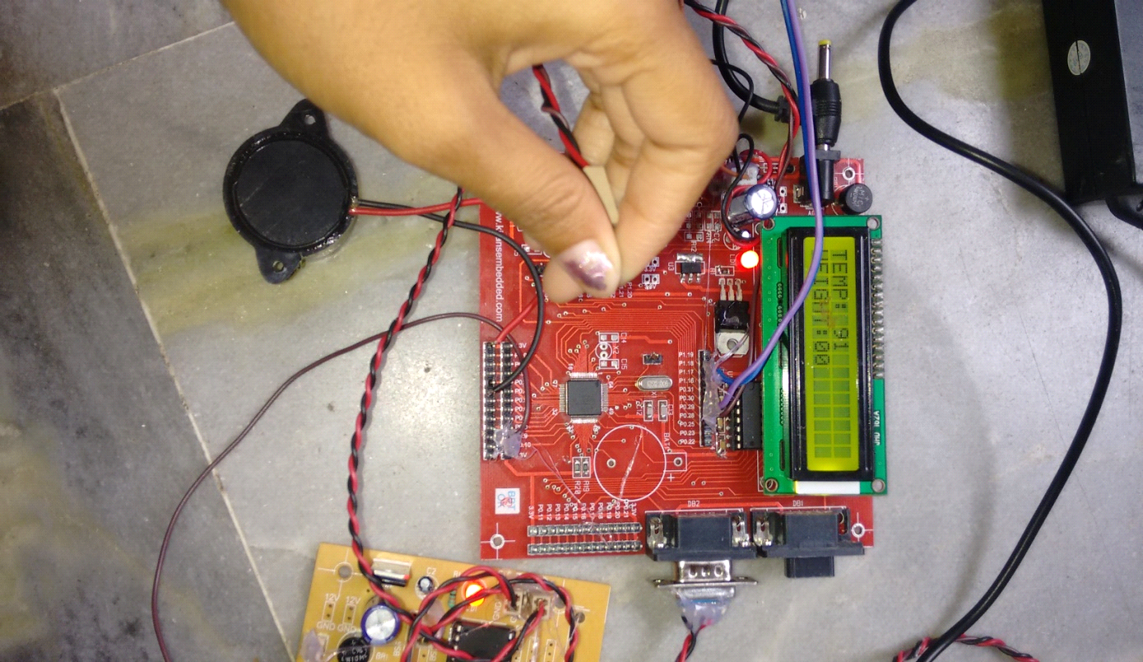

Fig 5.3: Temperature values

The temperature here obtained is usually in Fahrenheit and the displayed values can also be changed to Celsius values using basic formulas. The temperature sensor gives out the values in terms of Celsius which later the values have been programmed using conversion formula into Fahrenheit.

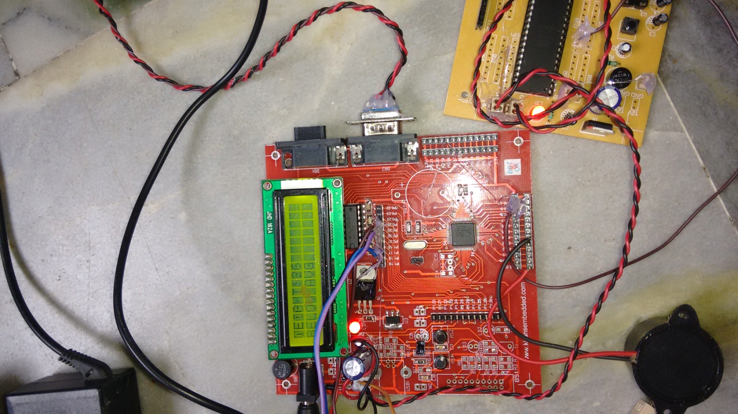

Fig 5.4 Weight is displayed on the screen

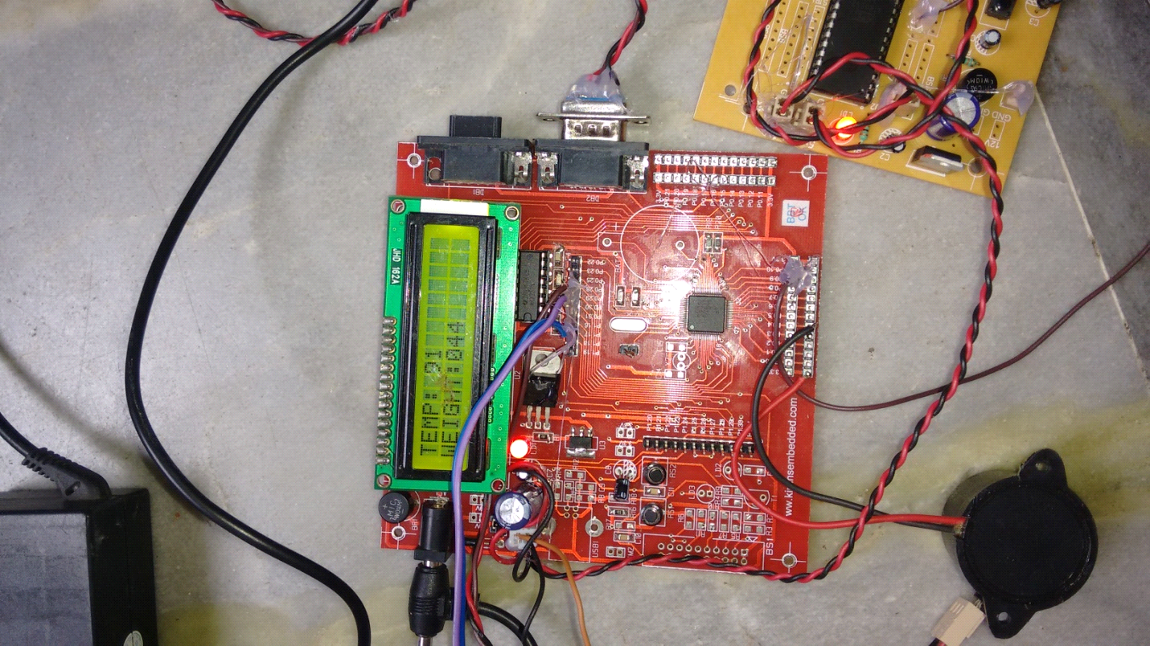Later the weight of the human is recorded, when the weight is below 56 kgs. The weight will be displayed onto the lcd as below average.

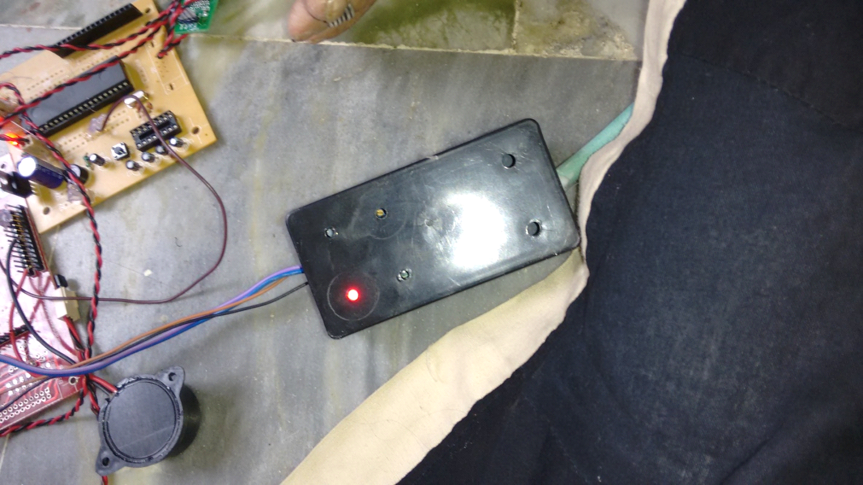

Fig 5.5 BP INDICATOR

The blood pressure will be measured when the red light is seen on the box,

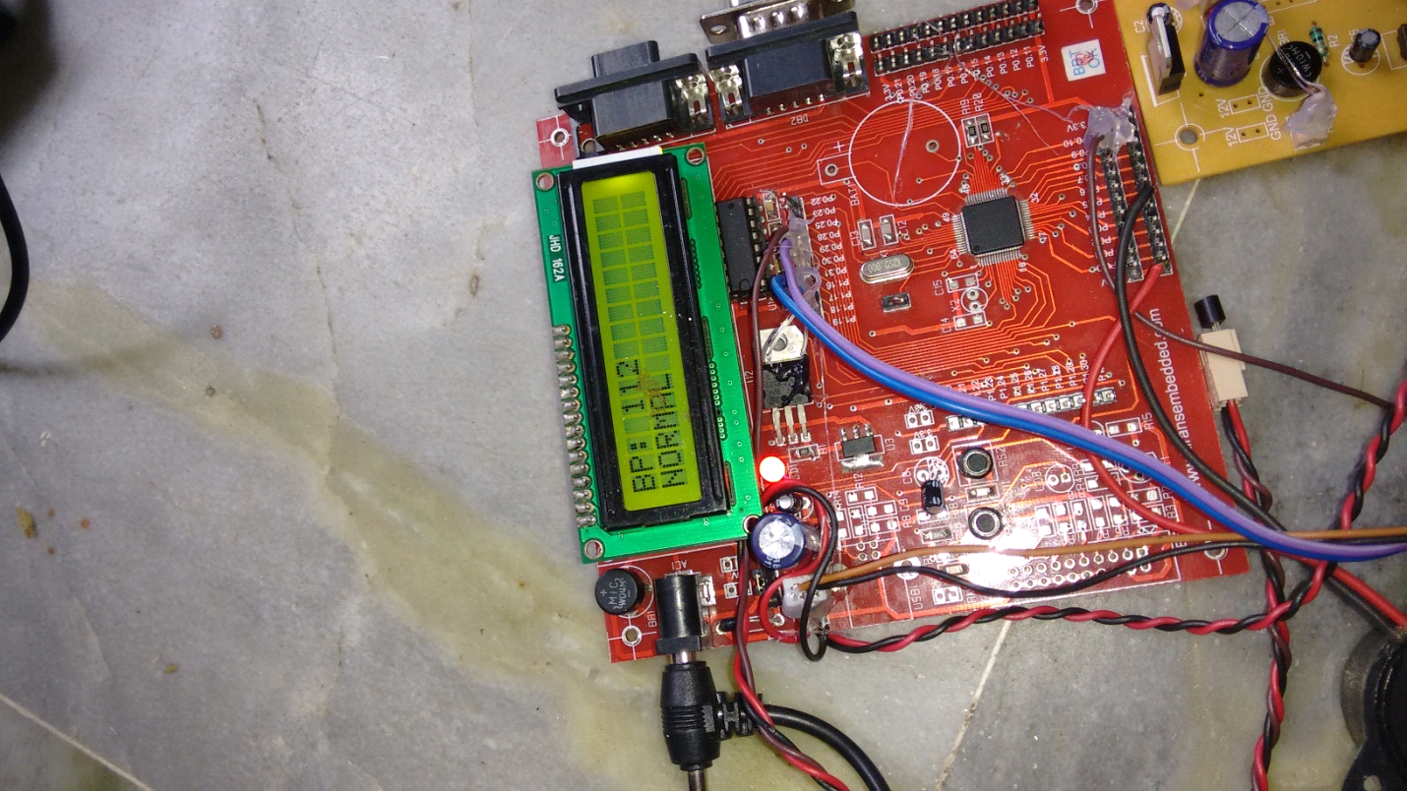

When the blood pressure goes high the message is sent to the number from gsm modem,

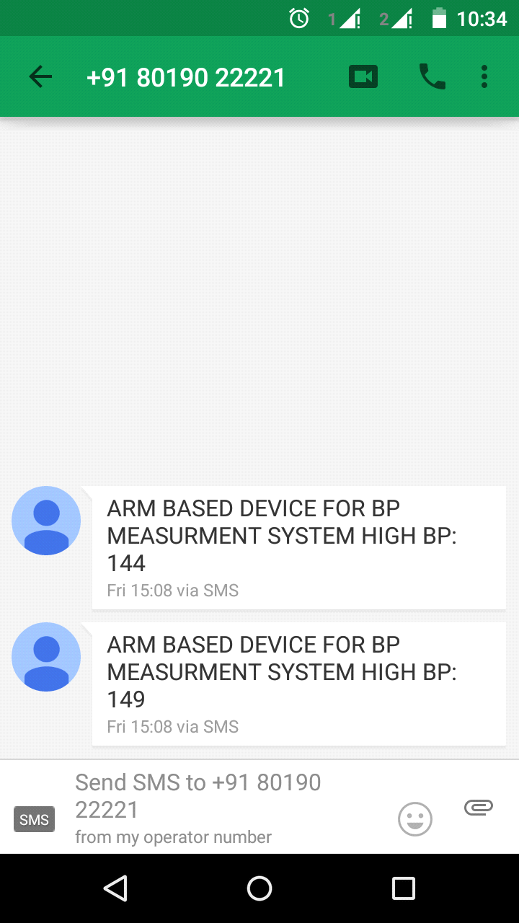

Fig 5.6 Message received on the mobile phone

The necessary precautions can be taken to reduce blood pressure when there is an issue of increased blood pressure and can be soon consulted to a doctor.

**SUMMARY:**

In this chapter, the simulation results along with the snapshots are displayed for each interval of time.

**CHAPTER 6**

**CONCLUSION AND FUTURE WORK**

**6.1 CONCLUSION**

The system designed hence provides accurate measurement of blood pressure, weight and temperature in case of pregnant women. This project is mainly built to constantly monitor blood pressure in pregnant women and take preventive measures against preeclampsia i.e. hypertension in pregnant women. The strokes seizures in pregnant women can also be prevented known as eclampsia causing fetal complications and sudden death. The sensor parameters are used here to test the time to time daily basis temperature of the women at home based remedies for constant monitoring. The weight of the subject is also taken into consideration for further preventive measures which is proven to be important to be monitored on weekly basis. These parameters will be sent to the doctor and patient through GSM / GPRS Modem. There are many ongoing researches on patient monitoring system using GSM / GPRS and the main purpose behind these researches is to make this system more compact, easily available at affordable price. New technologies could also enhance the performance of the final project.

**6.2 FUTURE SCOPE**

In the near future, the system can be further extended to monitor more than a single women and send it to the doctor through server and internet applications. Also the system can be minimized by developing it on Industrial platform and reducing its complexity and making it a small scale project flexible to use.

**References**

[1] T. G. Pickering*, et al.*, "Ambulatory blood-pressure monitoring," New England Journal of Medicine,vol. 354,2006, pp. 2368-2374.

[2] The American Society of Hypertension is publishing a series of Position Papers in their official journals throughout the 2008 - 2009 years. The following Position Paper originally appeared: JASH.

2008; 2(6):484–494.

[3] Deign of Low Cost Blood Pressure and Body Temperature interface

Johevajile K.N Mazima, Michael Kisangiri, Dina Machuve

International Journal of Emerging Science and Engineering (IJESE) ISSN: 2319–6378, Volume-1, Issue-10, August 2013.

[4] Sensors based Wearable and Systems for Detection of Human Movement and Fall

S K Saidulu1, B Karunaiah2, K V Murali Mohan3

1.S K Saidulu , pursuing M.Tech (ECE) from Holy Mary Institute of Technology and science (HITS), Bogaram, Keesara, JNTUH, Hyderabad, A.P, INDIA

2.B Karunaiah, working as a Professor (ECE) at Holy Mary Institute of Technology and science (HITS), Bogaram, Keesara, JNTUH, Hyderabad, A.P, INDIA

3.K V Murali Mohan, working as a Professor and HOD (ECE) at Holy Mary Institute of Technology and science (HITS), Bogaram, Keesara, Hyderabad., Affiliated to JNTUH, Hyderabad, A.P, INDIA.

[5]

**APPENDIX A**

**PROGRAM USED IN THE PROPOSED SYSTEM**

**MAIN PROGRAM**

**#include <stdio.h>**

**#include <LPC214x.H> /* LPC214x definitions */**

**#include "Serial.h"**

**#include "lcd.h"**

**#include "adc.h"**

**#include "Timer.h"**

**#define Vref 33/10**

**unsigned char str[100];**

**#define SWITCH (1 << 17)**

**#define BUZ (1 << 4)**

**#define SWITCH_MASK SWITCH**

**#define LED_MASK BUZ**

**#define SW_IO_DIR IODIR1**

**#define LED_IO_DIR IODIR0**

**#define INIT_SWITCHES() (SW_IO_DIR &= ~SWITCH_MASK)**

**#define INIT_LEDS() (LED_IO_DIR |= LED_MASK)**

**#define DEV_SET IOSET0**

**#define DEV_CLR IOCLR0**

**#define SW_IO_PIN IOPIN1**

**unsigned int tem,bp;**

**void delayms(int j) {**

**unsigned int i;**

**unsigned int k;**

**i = 0;**

**k = 0;**

**while (i != j) {**

**k = 0;**

**while (k != 14746) { k++; }**

**i++;**

**}**

**}**

**extern long volatile timeval;**

**void wait(int count)**

**{**

**int j=0,i=0;**

**for(j=0;j<count;j++)**

**{**

**/// At 60Mhz, the below loop introduces delay of 10 us**

**for(i=0;i<3500;i++);**

**}**

**}**

**void process_temp_sensor_adc(void)**

**{**

**unsigned long temp1,temp2;**

**unsigned short adc_value = 0;**

**adc_value = adc_read(ADC0, CHANNEL_1);**

**lcd_clear();**

**temp1=(unsigned long) (adc_value * Vref) >> 10UL;**

**temp2=(unsigned long) ((adc_value * Vref * 100) >> 10) % 10000;**

**tem=(temp2*1.8)+32;**

**}**

**void process_adc(void)**

**{**

**unsigned long temp1,temp2;**

**unsigned short adc_value = 0;**

**adc_value = adc_read(ADC0, CHANNEL_2);**

**lcd_clear();**

**temp1=(unsigned long) (adc_value * Vref) >> 10UL;**

**temp2=(unsigned long) ((adc_value * Vref * 100) >> 10) % 10000;**

**bp=temp2/2;**

**}**

**unsigned int wei=0;**

**int main (void)**

**{**

**unsigned int k;**

**unsigned char i,j,c,I,t,z;**

**unsigned int sw_mask;**

**uart0_init(); // Initialize UART0**

**uart1_init();**

**init_adc0();**

**init_lcd(); // Initialize LCD**

**INIT_LEDS(); // configure the gpio's connected by LEDs.**

**INIT_SWITCHES(); // configure the gpio's connected by Switches.**

**DEV_SET=BUZ;**

**lcd_clear();**

**lcd_putstring(0,"ARM BASED BP,TEMP");**

**lcd_putstring(1,"WEIGHT MEASURMENT");**

**delayms(1000);**

**lcd_clear();**

**while(1)**

**{**

**DEV_SET=BUZ;**

**lcd_clear();**

**process_temp_sensor_adc(); // Raed Temperature value and display it on second line of LCD**

**lcd_putstring(0,"TEMP: ");**

**integer_lcd(tem);**

**sw_mask = SW_IO_PIN & SWITCH_MASK;**

**if((sw_mask & (1 << 17)))**

**{**

**process_adc();**

**if(bp<110)**

**{**

**DEV_CLR=BUZ;**

**lcd_clear();**

**lcd_putstring(0,"BP: ");**

**integer_lcd(bp);**

**lcd_putstring(1,"LOW BP");**

**delayms(1000);**

**lcd_clear();**

**lcd_putstring(0,"MESSAGE SENDING....");**

**delayms(1000);**

**uart0_puts("AT+CMGS=");**

**uart0_putc('"');**

**delayms(1000);**

**uart0_puts("7673982153");**

**uart0_putc('"');**

**delayms(200);**

**uart0_putc(0x0d);**

**delayms(200);**

**uart0_puts("ARM BASED DEVICE FOR BP MEASURMENT SYSTEM\r\n");**

**delayms(100);**

**uart0_puts("LOW BP: ");**

**serial_int(bp);**

**delayms(2000);**

**uart0_putc(0x1a);**

**lcd_command_write(0x01);**

**lcd_putstring(0,"MESSAGE SENT");**

**delayms(1000);**

**uart0_putc(0x1a);**

**delayms(1000);**

**DEV_SET=BUZ;**

**}**

**else if(bp>140)**

**{**

**DEV_CLR=BUZ;**

**lcd_clear();**

**lcd_putstring(0,"BP: ");**

**integer_lcd(bp);**

**lcd_putstring(1,"HIGH BP");**

**delayms(1000);**

**lcd_clear();**

**lcd_putstring(0,"MESSAGE SENDING....");**

**delayms(1000);**

**uart0_puts("AT+CMGS=");**

**uart0_putc('"');**

**delayms(1000);**

**uart0_puts("7673982153");**

**uart0_putc('"');**

**delayms(200);**

**uart0_putc(0x0d);**

**delayms(200);**

**uart0_puts("ARM BASED DEVICE FOR BP MEASURMENT SYSTEM\r\n");**

**delayms(100);**

**uart0_puts("HIGH BP: ");**

**serial_int(bp);**

**delayms(2000);**

**uart0_putc(0x1a);**

**lcd_command_write(0x01);**

**lcd_putstring(0,"MESSAGE SENT");**

**delayms(1000);**

**uart0_putc(0x1a);**

**delayms(1000);**

**DEV_SET=BUZ;**

**}**

**else**

**{**

**lcd_clear();**

**lcd_putstring(0,"BP: ");**

**integer_lcd(bp);**

**lcd_putstring(1,"NORMAL");**

**delayms(1000);**

**lcd_clear();**

**}**

**}**

**i=0;**

**do**

**{**

**if(U1LSR & 0x01)**

**{**

**c= getkey1();**

**str[i++] = c;**

**}**

**}while(c!=0x0a);**

**wei=(str[1]-48)*100+(str[2]-48)*10+(str[3]-48);**

**//lcd_clear();**

**lcd_putstring(1,"WEIGHT:0");**

**if(wei>200)**

**wei=0;**

**integer_lcd(wei);**

**delayms(1000);**

**if(wei>10&&wei<54)**

**{**

**lcd_clear();**

**lcd_putstring(0,"WEIGHT:");**

**integer_lcd(wei);**

**lcd_putstring(1,"BELOW AVG");**

**delayms(1000);**

**}**

**if(wei>68)**

**{**

**lcd_clear();**

**lcd_putstring(0,"WEIGHT:");**

**integer_lcd(wei);**

**lcd_putstring(1,"ABOVE AVG");**

**delayms(1000);**

**}**

**if(tem>105)**

**{**

**DEV_CLR=BUZ;**

**lcd_clear();**

**lcd_putstring(0,"TEMP: ");**

**integer_lcd(tem);**

**lcd_putstring(1,"HIGH TEMPERATURE");**

**delayms(1000);**

**}**

**}**

**}**

**SERIAL PROGRAM :**

**#include <LPC21xx.H> /* LPC21xx definitions */**

**#include "Serial.h"**

**#define CR 0x0D**

**/* implementation of putchar (also used by printf function to output data) */**

**int sendchar (int ch) { /* Write character to Serial Port */**

**if (ch == '\n') {**

**while (!(U1LSR & 0x20));**

**U1THR = CR; /* output CR */**

**}**

**while (!(U1LSR & 0x20));**

**return (U1THR = ch);**

**}**

**int getkey (void) { /* Read character from Serial Port */**

**while (!(U0LSR & 0x01));**

**return (U0RBR);**

**}**

**int getkey1 (void) { /* Read character from Serial Port */**

**while (!(U1LSR & 0x01));**

**return (U1RBR);**

**}**

**void uart1_init()**

**{**

**/* initialize the serial interface */**

**// PINSEL0 = 0x00050000; /* Enable RxD1 and TxD1 */**

**PINSEL0 = (PINSEL0 & ~(3 << 16)) | (1 << 16);**

**PINSEL0 = (PINSEL0 & ~(3 << 18)) | (1 << 18);**

**U1LCR = 0x83; /* 8 bits, no Parity, 1 Stop bit */**

**U1DLL = 97; /* 9600 Baud Rate @ 15MHz VPB Clock */**

**U1LCR = 0x03; /* DLAB = 0 */**

**}**

**//------------------------------------------------------------------------------------------------//**

**//---------------------------- Function for send character 1 time via UART1-----------------------//**

**//------------------------------------------------------------------------------------------------//**

**void uart1_putc(char c)**

**{**

**while(!(U1LSR & 0x20)); // Wait until UART1 ready to send character**

**U1THR = c; // Send character**

**}**

**//------------------------------------------------------------------------------------------------//**

**//---------------------------- Function for send string via UART1---------------------------------//**

**//------------------------------------------------------------------------------------------------//**

**void uart1_puts(char *p)**

**{**

**while(*p) // Point to character**

**{**

**uart1_putc(*p++); // Send character then point to next character**

**}**

**}**

**//------------------------------------------------------------------------------------------------//**

**//---------------------------- Function for Initial UART0 ----------------------------------------//**

**//------------------------------------------------------------------------------------------------//**

**void uart0_init()**

**{**

**/* initialize the serial interface */**

**// PINSEL0 = 0x00000005; /* Enable RxD0 and TxD0 */**

**PINSEL0 = (PINSEL0 & ~(3 << 0)) | (1 << 0);**

**PINSEL0 = (PINSEL0 & ~(3 << 2)) | (1 << 2);**

**U0LCR = 0x83; /* 8 bits, no Parity, 1 Stop bit */**

**U0DLL = 97; /* 9600 Baud Rate @ 15MHz VPB Clock */**

**U0LCR = 0x03; /* DLAB = 0 */**

**}**

**//------------------------------------------------------------------------------------------------//**

**//---------------------------- Function for send character 1 time via UART0-----------------------//**

**//------------------------------------------------------------------------------------------------//**

**void uart0_putc(char c)**

**{**

**while(!(U0LSR & 0x20)); // Wait until UART0 ready to send character**

**U0THR = c; // Send character**

**}**

**//------------------------------------------------------------------------------------------------//**

**//---------------------------- Function for send string via UART1---------------------------------//**

**//------------------------------------------------------------------------------------------------//**

**void uart0_puts(char *p)**

**{**

**while(*p) // Point to character**

**{**

**uart0_putc(*p++); // Send character then point to next character**

**}**

**}**

**void serial_int(int n)**

**{**

**//n=n>>1;**

**unsigned char c[6];**

**unsigned int i=0;**

**if(n==0)**

**{**

**uart0_putc('0');**

**delayms(100);**

**}**

**while(n>0)**

**{**

**c[i++]=(n%10)+48;**

**n/=10;**

**}**

**while(i-->=1)**

**{**

**uart0_putc(c[i]);**

**delayms(100);**

**}**

**}**

**void serial_int1(int n)**

**{**

**//n=n>>1;**

**unsigned char c[6];**

**unsigned int i=0;**

**if(n==0)**

**{**

**uart1_putc('0');**

**}**

**while(n>0)**

**{**

**c[i++]=(n%10)+48;**

**n/=10;**

**}**

**while(i-->=1)**

**{**

**uart1_putc(c[i]);**

**}**

**}**

**LCD PROGRAM :**

**#include <LPC214x.H> /* LPC214x definitions */**

**#include "lcd.h"**

**#define LCD_BACK_LIGHT_TIMEOUT 1000**

**#define LCD_BACKLIGHT (1 << 21)**

**#define LCD_BACK_LIGHT_DIR IO1DIR**

**#define LCD_BACK_LIGHT_SET IO1SET**

**#define LCD_BACK_LIGHT_CLR IO1CLR**

**#define LCD_DATA_DIR IO0DIR**

**#define LCD_DATA_SET IO0SET**

**#define LCD_DATA_CLR IO0CLR**

**#define LCD_CTRL_DIR IO1DIR**

**#define LCD_CTRL_SET IO1SET**

**#define LCD_CTRL_CLR IO1CLR**

**#define LCDRS (1 << 24)**

**#define LCDRW (1 << 23)**

**#define LCDEN (1 << 22)**

**#define LCD_D4 (1 << 10)**

**#define LCD_D5 (1 << 12)**

**#define LCD_D6 (1 << 11)**

**#define LCD_D7 (1 << 13)**

**#define LCD_DATA_MASK (LCD_D4 | LCD_D5 | LCD_D6 | LCD_D7)**

**#define LCD_BUSY_FLAG LCD_D7**

**#define LCD_CONTROL_MASK 0x01C00000**

**void delay(int count)**

**{**

**int j=0,i=0;**

**for(j=0;j<count;j++)**

**{**

**/* At 60Mhz, the below loop introduces**

**delay of 10 us */**

**for(i=0;i<35;i++);**

**}**

**}**

**void wait_lcd( void )**

**{**

**LCD_CTRL_CLR |= LCDRS;**

**LCD_CTRL_SET |= LCDRW |LCDEN;**

**while(IO1PIN & LCD_BUSY_FLAG); /* wait for busy flag to become low */**

**LCD_CTRL_CLR |= LCDEN | LCDRW;**

**LCD_DATA_DIR |= LCD_DATA_MASK;**

**delay(10);**

**}**

**void lcd_command_write( unsigned char command )**

**{**

**unsigned char temp=0;**

**unsigned int temp1=0;**

**temp=command;**

**temp=(temp>>4)&0x0F;**

**temp1=(temp<<10)&LCD_DATA_MASK;**

**LCD_CTRL_CLR = LCDRS;**

**LCD_CTRL_SET = LCDEN;**

**LCD_DATA_CLR = LCD_DATA_MASK;**

**LCD_DATA_SET = temp1;**

**delay(10000);**

**LCD_CTRL_CLR = LCDEN;**

**temp=command;**

**temp&=0x0F;**

**temp1=(temp<<10)&LCD_DATA_MASK;**

**delay(100*2);**

**LCD_CTRL_CLR |= LCDRS;**

**LCD_CTRL_SET |= LCDEN;**

**LCD_DATA_CLR = LCD_DATA_MASK;**

**LCD_DATA_SET = temp1;**

**delay(10000);**

**LCD_CTRL_CLR |= LCDEN;**

**wait_lcd();**

**}**

**void set_lcd_port_output( void )**

**{**

**LCD_CTRL_DIR |= ( LCDEN | LCDRS | LCDRW );**

**LCD_CTRL_CLR |= ( LCDEN | LCDRS | LCDRW );**

**LCD_DATA_DIR |= LCD_DATA_MASK;**

**}**

**void lcd_clear( void)**

**{**

**lcd_command_write( 0x01 );**

**}**

**int lcd_gotoxy( unsigned int x, unsigned int y)**

**{**

**int retval = 0;**

**if( (x > 1) && (y > 15) )**

**{**

**retval = -1;**

**} else {**

**if( x == 0 )**

**{**

**lcd_command_write( 0x80 + y ); /* command - position cursor at 0x00 (0x80 + 0x00 ) */**

**} else if( x==1 ){**

**lcd_command_write( 0xC0 + y ); /* command - position cursor at 0x40 (0x80 + 0x00 ) */**

**}**

**}**

**return retval;**

**}**

**void lcd_data_write( unsigned char data )**

**{**

**unsigned char temp=0;**

**unsigned int temp1=0;**

**temp=data;**

**temp=(temp>>4)&0x0F;**

**temp1=(temp<<10)&LCD_DATA_MASK;**

**LCD_CTRL_SET |= LCDEN|LCDRS;**

**LCD_DATA_CLR = LCD_DATA_MASK;**

**LCD_DATA_SET = temp1;**

**LCD_CTRL_CLR |= LCDEN;**

**temp=data;**

**temp&=0x0F;**

**temp1=(temp<<10)&LCD_DATA_MASK;**

**LCD_CTRL_SET |= LCDEN|LCDRS;**

**LCD_DATA_CLR = LCD_DATA_MASK;**

**LCD_DATA_SET = temp1;**

**LCD_CTRL_CLR |= LCDEN;**

**wait_lcd();**

**}**

**void lcd_putchar( int c )**

**{**

**lcd_data_write( c );**

**}**

**void lcd_putstring( unsigned char line, char *string )**

**{**

**unsigned char len = MAX_CHAR_IN_ONE_LINE;**

**lcd_gotoxy( line, 0 );**

**while(*string != '\0' && len--)**

**{**

**lcd_putchar( *string );**

**string++;**

**}**

**}**

**void integer_lcd(int n)**

**{**

**//n=n>>1;**

**unsigned char c[6];**

**unsigned int i=0;**

**if(n==0)**

**{**

**lcd_putchar('0');**

**}**

**while(n>0)**

**{**

**c[i++]=(n%10)+48;**

**n/=10;**

**}**

**while(i-->=1)**

**{**

**lcd_putchar(c[i]);**

**}**

**}**

**void init_lcd( void )**

**{**

**set_lcd_port_output();**

**delay(100*100);**

**lcd_command_write(0x28); /* 4-bit interface, two line, 5X7 dots. */**

**lcd_clear() ; /* LCD clear */**

**lcd_command_write(0x02); /* cursor home */**

**lcd_command_write(0x06); /* cursor move direction */**

**lcd_command_write(0x0C) ; /* display on */**

**lcd_gotoxy(0, 0);**

**lcd_clear();**

**}**

**ADC PROGRAM :**

**#include "adc.h"**

**#include <LPC214x.H> /* LPC214x definitions */**

**/\*\***

**\*\*\*\*\*\*\*\*\*\*\*\*\*\*\*\*\*\*\*\*\*\*\*\*\*\*\*\*\*\*\*\*\*\*\*\*\*\*\*\*\*\*\*\*\*\*\*\*\*\*\*\*\*\*\*\*\*\*\*\*\*\*\*\*\*\*\*\*\*\*\*\*\*\*\*\*\*\*\***

**Function Name :init_adc0()**

**Description : Initialises the ADC0**

**Input : None**

**Output : None**

**Note :**

**\*\*\*\*\*\*\*\*\*\*\*\*\*\*\*\*\*\*\*\*\*\*\*\*\*\*\*\*\*\*\*\*\*\*\*\*\*\*\*\*\*\*\*\*\*\*\*\*\*\*\*\*\*\*\*\*\*\*\*\*\*\*\*\*\*\*\*\*\*\*\*\*\*\*\*\*\*\*\***

**\*/**

**void init_adc0(void)**

**{**

**// PINSEL1 = (PINSEL1 & ~(3 << 28)) | (1 << 28);**

**PINSEL1 = 0x15040000;**

**}**

**/\*\***

**\*\*\*\*\*\*\*\*\*\*\*\*\*\*\*\*\*\*\*\*\*\*\*\*\*\*\*\*\*\*\*\*\*\*\*\*\*\*\*\*\*\*\*\*\*\*\*\*\*\*\*\*\*\*\*\*\*\*\*\*\*\*\*\*\*\*\*\*\*\*\*\*\*\*\*\*\*\*\***

**Function Name :init_adc1()**

**Description : Initialises the ADC1**

**Input : None**

**Output : None**

**Note :**

**\*\*\*\*\*\*\*\*\*\*\*\*\*\*\*\*\*\*\*\*\*\*\*\*\*\*\*\*\*\*\*\*\*\*\*\*\*\*\*\*\*\*\*\*\*\*\*\*\*\*\*\*\*\*\*\*\*\*\*\*\*\*\*\*\*\*\*\*\*\*\*\*\*\*\*\*\*\*\***

**\*/**

**void init_adc1(void)**

**{**

**}**

**/\*\***

**\*\*\*\*\*\*\*\*\*\*\*\*\*\*\*\*\*\*\*\*\*\*\*\*\*\*\*\*\*\*\*\*\*\*\*\*\*\*\*\*\*\*\*\*\*\*\*\*\*\*\*\*\*\*\*\*\*\*\*\*\*\*\*\*\*\*\*\*\*\*\*\*\*\*\*\*\*\*\***

**Function Name : adc_read()**

**Description :**

**Input : adc number,channel**

**Output : 10 bit AD value**

**Note :**

**\*\*\*\*\*\*\*\*\*\*\*\*\*\*\*\*\*\*\*\*\*\*\*\*\*\*\*\*\*\*\*\*\*\*\*\*\*\*\*\*\*\*\*\*\*\*\*\*\*\*\*\*\*\*\*\*\*\*\*\*\*\*\*\*\*\*\*\*\*\*\*\*\*\*\*\*\*\*\***

**\*/**

**unsigned short adc_read(unsigned char adc_num, unsigned char ch)**

**{**

**unsigned int i=0;**

**switch(adc_num)**

**{**

**case ADC0:**

**AD0CR = 0x00200D00 | (1<<ch); // select channel**

**AD0CR |= 0x01000000; // Start A/D Conversion**

**do**

**{**

**i = AD0GDR; // Read A/D Data Register**

**} while ((i & 0x80000000) == 0); // Wait for end of A/D Conversion**

**break;**

**case ADC1:**

**AD1CR = 0x00200D00 | (1<<ch); // select channel**

**AD1CR |= 0x01000000; // Start A/D Conversion**

**do**

**{**

**i = AD1GDR; // Read A/D Data Register**

**} while ((i & 0x80000000) == 0); // Wait for end of A/D Conversion**

**break;**

**}**

**return (i >> 6) & 0x03FF; // bit 6:15 is 10 bit AD value**

**}**

**TIMER PROGRAM :**

**/******************************************************************************/**

**/* This file is part of the uVision/ARM development tools */**

**/* Copyright KEIL ELEKTRONIK GmbH 2002-2004 */**

**/******************************************************************************/**

**/* */**

**/* TIME.C: Time Functions for 100Hz Clock Tick */**

**/* */**

**/******************************************************************************/**

**#include <LPC21XX.H> // LPC21XX Peripheral Registers**

**#include "Timer.h"**

**long timeval;**

**void tc0 (void) __attribute__ ((interrupt)); // Generate Interrupt**

**/* Setup the Timer Counter 0 Interrupt */**

**void init_timer (void) {**

**T0MR0 = 149999; // 10mSec = 150.000-1 counts**

**T0MCR = 3; // Interrupt and Reset on MR0**

**T0TCR = 1; // Timer0 Enable**

**VICVectAddr0 = (unsigned long)tc0; // set interrupt vector in 0**

**VICVectCntl0 = 0x20 | 4; // use it for Timer 0 Interrupt**

**VICIntEnable = 0x00000010; // Enable Timer0 Interrupt**

**}**

**/* Timer Counter 0 Interrupt executes each 10ms @ 60 MHz CPU Clock */**

**void tc0 (void) {**

**timeval++;**

**T0IR = 1; // Clear interrupt flag**

**VICVectAddr = 0; // Acknowledge Interrupt**

**}**

**LOAD CELL PROGRAM :**

**#include<reg52.h>**

**#include<lcd.h>**

**sbit ADDO = P1^0;**

**sbit ADSK = P1^1;**

**unsigned long ReadCount(void){**

**unsigned long Count;**

**unsigned char i;**

**ADDO=1;**

**ADSK=0;**

**Count=0;**

**while(ADDO);**

**for (i=0;i<24;i++){**

**ADSK=1;**

**Count=Count<<1;**

**ADSK=0;**

**if(ADDO) Count++;**

**}**

**ADSK=1;**

**Count=Count^0x800000;**

**ADSK=0;**

**Count=Count/1000;**

**Count=Count-8407;**

**return(Count);**

**}**

**void serial_intr(void) interrupt 4**

**{**

**if(TI) //if transmit interrupt, clear TI**

**TI=0;**

**if(RI) //if receive interrupt, clear RI**

**{**

**write_lcd(SBUF); //display received byte**

**RI=0;**

**}**

**}**

**void main(void)**

**{**

**float load;**

**TMOD=0x20; //set timer1 to mode2**

**SCON=0x50; //set serial communication parameters,**

**// mode1=1 start bit, 8 data bits, 1 stop bit, no parity & receive enable**

**IE=0x90; //set global interrupt bit EA=1, serial interrupt bit ES=1**

**TH1=0xfd; //set 9600 baud rate**

**TR1=1; //start timer1**

**init_lcd();**

**display_lcd("LOAD CELL");**

**delay_ms(1000);**

**while(1)**

**{**

**load=ReadCount();**

**cmd_lcd(0x01);**

**if(load<0)**

**load=0;**

**if(load<10)**

**{**

**SBUF='0';**

**delay_ms(50);**

**SBUF='0';**

**delay_ms(50);**

**write_lcd('0');**

**write_lcd('0');**

**integer_lcd(load);**

**integer_ser(load);**

**delay_ms(50);**

**SBUF=0X0A;**

**}**

**else if(load<100)**

**{**

**SBUF='0';**

**delay_ms(50);**

**write_lcd('0');**

**integer_lcd(load);**

**integer_ser(load);**

**delay_ms(50);**

**SBUF=0X0A;**

**}**

**else**

**{**

**integer_lcd(load);**

**integer_ser(load);**

**delay_ms(50);**

**SBUF=0X0A;**

**}**

**delay_ms(300);**

**}**

**}**

**APPENDIX B**

**ALGORITHM OF THE PROPOSED SYSTEM**

The algorithmic flow for generating the output is as follows:

* Start the program
* Let the initial values of temperature, pressure and weight be displayed on LCD.
* If temperature is interfaced then, temperature>= initial value
* If weight is applied then, weight >= initial value
* After the arm band is placed record the values of blood pressure and display it on lcd.
* If blood pressure < 110 , display as low temperature.
* If blood pressure >140, display as high temperature.
* Next buzzer is active and beeps if pressure is recorded to be high.
* It sends the message to the given number using GSM modem.

**APPENDIX C**

**FLOWCHART OF THE PROPOSED SYSTEM**

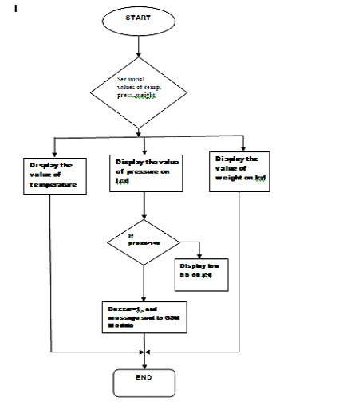

**Fig:** **FLOW CHART**